**Integrating Pipedrive with Teamchat**

**Step 1:**

As there is no authentication method like OAUTH so there is need of the Access token so we have the user to directly enter the his email and the password of the pipedrive account.

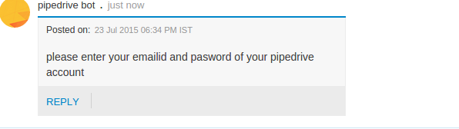

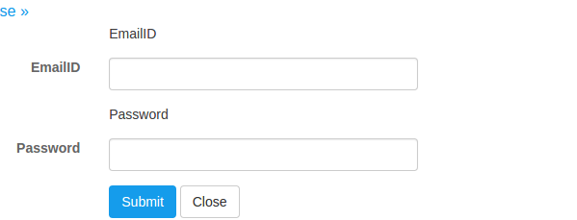

**Step 2:**

Exploring the api available to the developers through Pipedrive

they are available at :

**https://developers.pipedrive.com/v1**

that site appears like this

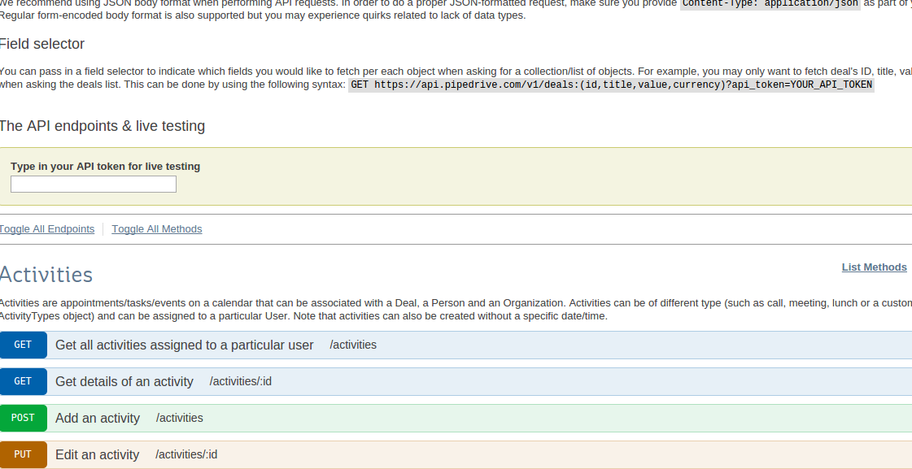

here there are the api available can be explored and the Json format can be checked and the data can be retrived.

**Step 3:**

After getting the mail id and password of the user the step comes of generating The API TOKEN

by using this url:

**api.pipedrive.com/v1/authorizations**

along with this the parameters required to passed are the email and the password of the user

that returns a JSON that looks like below image and you need to just remove the **api token**

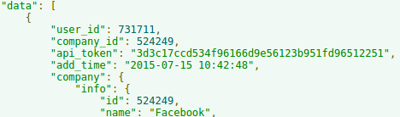

**Step 4**

Then there is dropdown of the all the deals in that are related to that pipedrive account.

So that user can choose the particular account and work with that and the details like deal stage and client name

this is done with this url:

<https://api.pipedrive.com/v1/deals?start=0&api_token>="{api_token}

this url needs the api_token that is fetched from the above json.

From here one can fetch the details like

**client name**

**stage of the deal**

**deal cost**

**etc.**

The JSON is in this manner:

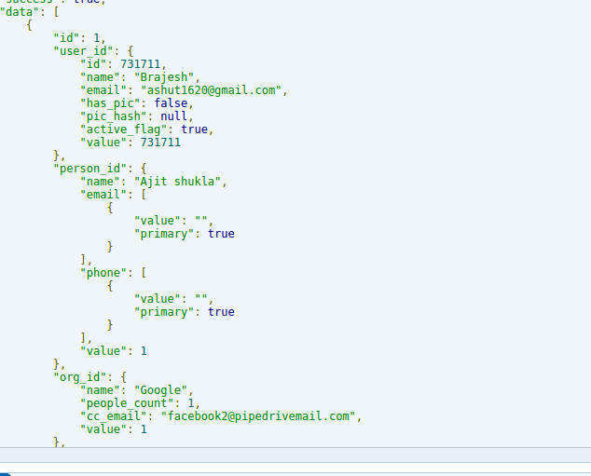

**Step 5:**

The push notification (similar to the webhook notification) that can be done through

this url

**https://api.pipedrive.com/v1/pushNotifications?api_token="**

**+ apikey;**

but along with there is an webhook url that need to added.

**http://interns.teamchat.com:8082/Pipedrive/notification**

as to get the push notification one needs to send some text in Json form i.e is this

**JSONObject jobj = new JSONObject();**

**jobj.put("user_id", userid);**

**jobj.put("subscription_url", webhookurl);**

**jobj.put("event", "*.*");**

**String jsonstring = jobj.toString();**

**So now shifting of the deals from one stage there is notification any change brings notification.**